Qualification
BTEC Level 3 - Applied Science
Center Name | Center Registration No
ABC Horizon Academy | 91667
Student name | Assessor name
Zeid Amjad Hamdan Zeid Alkilani | Mr. Tareq ZAINALDIN
Unit Number/Name
Unit 28: Sustainable Energy
Assignment number and title | Submitted on
- Impact of use of fossil fuels  - Alternative energy sources  - Benefits and disadvantages of the use of renewable energy | 31/03/2026

Student Declaration

Student signature: Zeid Alkilani Date: March/2026

Task.1
Provide publicity materials that describe, explain and evaluate the sourfces and uses of fossil fuels and the impact they have on human health.
•Describe where coal, oil and gas come from.
•Describe, explain and evaluate the environmental impact of the extraction and use of coal, oil and gas and how their use can have an impact on human health.
Task consider the following when producing your materials:
Extraction
•Where coal, oil and gas come from,
•How they are extracted by surface and underground mining,Offshore, onshore drilling and fracking
▪︎Uses- power generation,
▪︎As a fuel for transport, cooking, heating.
▪︎As a base for the production of other materials
▪︎Coking coal, carbon fibre, activated carbon, coal tar and its by-Products,
▪︎Crude oil and its by-products,
▪︎As a base for feedstock and pharmaceutical products
●Environmental and ecological effects
▪︎Emission of heat-trapping gases carbon dioxide, methane,water vapour, global warming, `greenhouse effect’ rise in sea Levels.
▪︎Risk of earthquakes leakage of fracking fluids and substantial use of water.
●Effect on climate
▪︎risk of drought, heatwaves, intensified storms
•Effect on human health of
▪︎Toxic air pollutants like mercury, sulfur dioxide, nitrous oxides lead, arsenic, volatile organic compounds, particulates.

Could Humans Ever Be Fossil Fuels In The Future?


Have you ever considered what will become of our remains in the distant future when we are long dead? We don’t mean in a few decades, or even a few hundred years, we mean eons into the future when the human race may have gone the way of the dinosaurs. Is it possible some of us may experience the transformative processes that have turned long-dead organisms into the substances we use to fuel our world today? In short, could humans ever become fossil fuels?

Fossil fuels are not dinosaurs
Rather than being dinosaurs, most of the organisms that became fossil fuels were far smaller in size and, in some cases (though not exclusively), died long before the “terrible lizards” started roaming the planet. As such, you are not pouring liquid dinosaur into your cars when you refuel, at least not in large amounts.
Until the mid-18th century, the word “fossil” actually referred to something that was “dug up” or the process of digging something up, rather than referring to a long-dead organism. The meaning we understand today was therefore a later development, and it was not until the mid-19th century that we started to see the term “fossil fuel” being used in its broader sense. IFLScience exciting 2023.Dr. Russell Moul
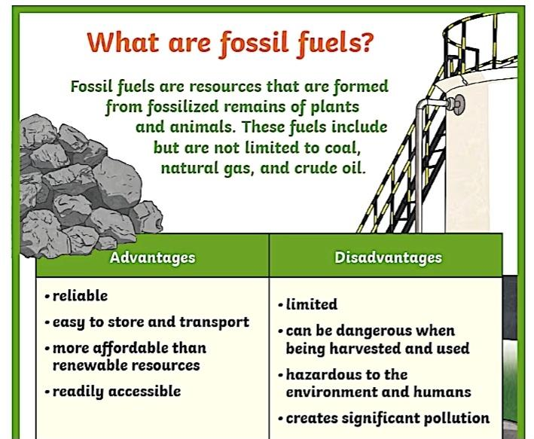

So, fossil fuels made from

- Coal: holds the energy that was once contained by plants living in swampy forests. When they died, their remains sunk to the bottom of the water where they experienced partial decay in an oxygen-deficient environment. This turned them into peat.
Over time, the wetlands dried out and other materials covered the peat. The pressure and heat caused by burial beneath these materials turned the plant material into what we call coal. Most of the coal we use today started out on this long process around 350-300 million years ago during the Carboniferous period (literally meaning “coal-bearing” period).


- Petroleum: (literally Latin for “rock oil”) mostly comes from a similar process that started in the prehistoric oceans. Here, ancient plankton sank to the ocean floor after they died. Their tiny bodies were then covered with more debris as they drifted down from the surface and mixed with sand, silt, and rock.
As with coal, the accompanying heat and pressure from these layers transformed the remains into what we would recognize as petroleum or crude oil. It should be noted that this process is not necessarily unique to marine microorganisms, however, as petroleum can also be recovered from prehistoric lakes where algae underwent the same process.
Petroleum comprises various hydrocarbon compounds and exists in liquid form. Generally speaking, the liquid pools deep underground in sedimentary rocks, but can also sometimes occur in hard rocks, such as fractured granite. It can also appear closer to the surface where it bubbles up as tar or bitumen.
Depending on its composition, petroleum’s color can vary quite a bit – if it contains few metals or sulfur, it can be lighter. In some cases, it can almost be clear.

- Natural gas: This fuel is mostly made of methane, though it can also contain small proportions of ethane, propane, butane, and pentane, which have been produced by long-dead marine microorganisms (some ancient terrestrial plants also produced natural gas when they decomposed).
Under the same conditions that produced petroleum, the gas appears as the organisms undergo transformations from the heat and pressure they experience as they are buried in oxygen-free environments. Methane is the lightest and simplest hydrocarbon. It is colorless and odorless in its natural state but is also highly flammable.
Once the gas has formed, it will try to rise to the surface, but its progress depends on the nature of the rock surrounding it. If the rock is porous and permeable (having large numbers of interconnected spaces), the gas can more easily escape.
Most of the gas deposits exploited today come from deposits in porous rock buried below impermeable rock. This type of gas is sometimes referred to as conventional natural gas. However, sometimes the gas is stuck in the tiny pores within some shale, sandstone, or other sedimentary rock formations. This gas is referred to as “shale gas” or “tight gas”, or sometimes unconventional gas. In other cases, the gas is located with crude oil deposits, which are then called associated natural gas.IFLScience 2023.Dr. Russell Moul

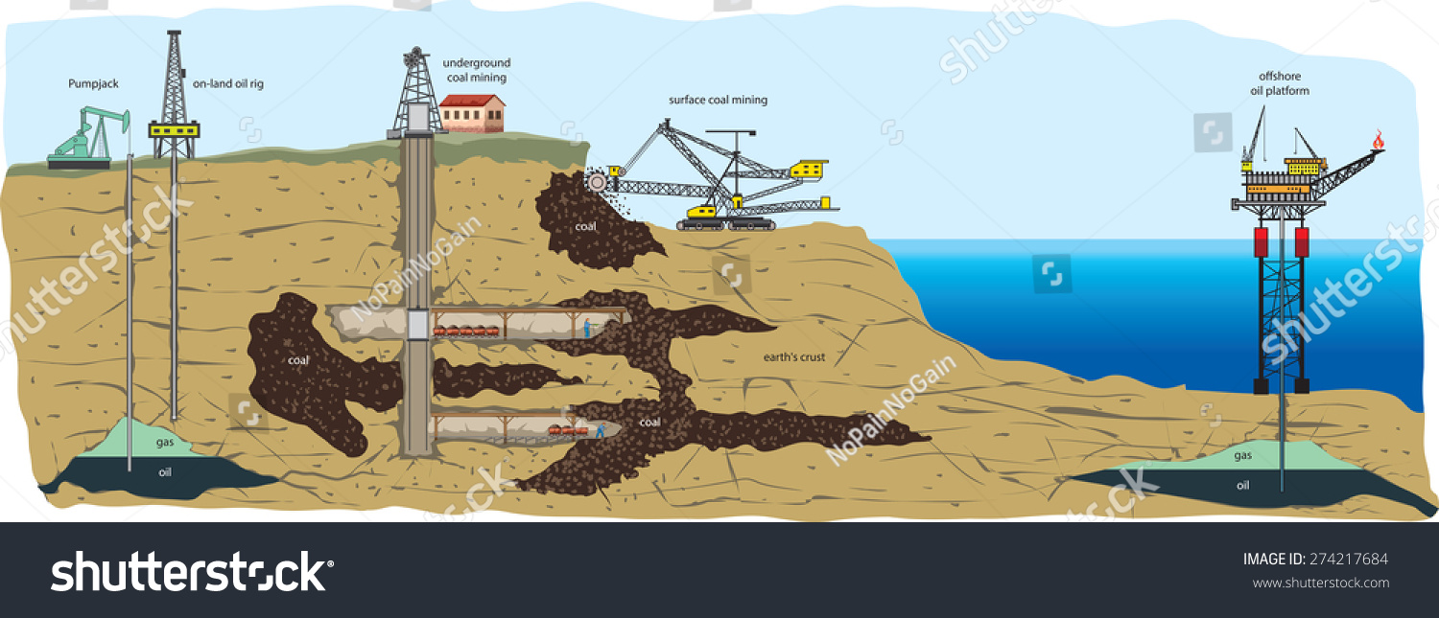
EXTRACTION

- Coal Extraction
Coal is extracted primarily through two methods depending on the depth of the seam.

•Surface Mining (Open-Cast/Open-Pit): Used when coal is less than 200 feet deep.
•Process: Machines remove “overburden” (soil and rock) to expose the coal seam.
•Strip Mining: Overburden is removed in strips, with waste from new strips filling previous, mined-out strips.
•Mountaintop Removal: Explosives are used to remove the tops of mountains to reach coal seams, often dumping debris into valleys.
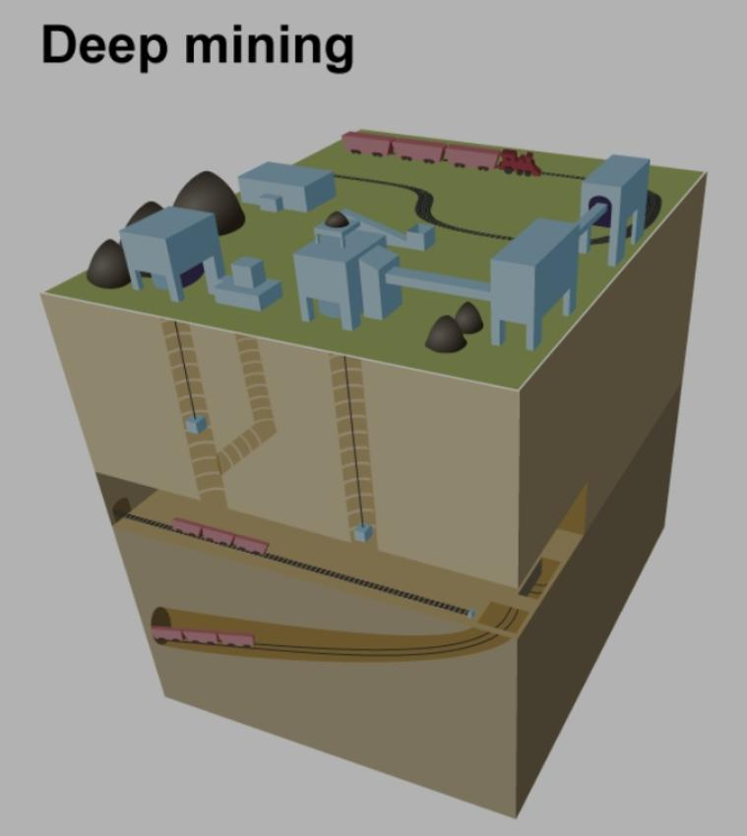
•Underground Mining (Deep Mining): Used for coal more than 200 feet below the surface.

Room-and-Pillar: Miners cut “rooms” into the coal seam, leaving “pillars” of coal to support the roof.
•Longwall Mining: A mechanical shearer cuts across a “long wall” of coal, allowing the roof to collapse behind it as it advances.
•Access: Miners and equipment reach the coal via vertical shafts or sloping tunnels. https://www.eia.gov/energyexplained/coal/mining-and-transportation.php

2. Oil and Gas Extraction
Oil and gas are extracted by drilling wells into underground reservoirs.
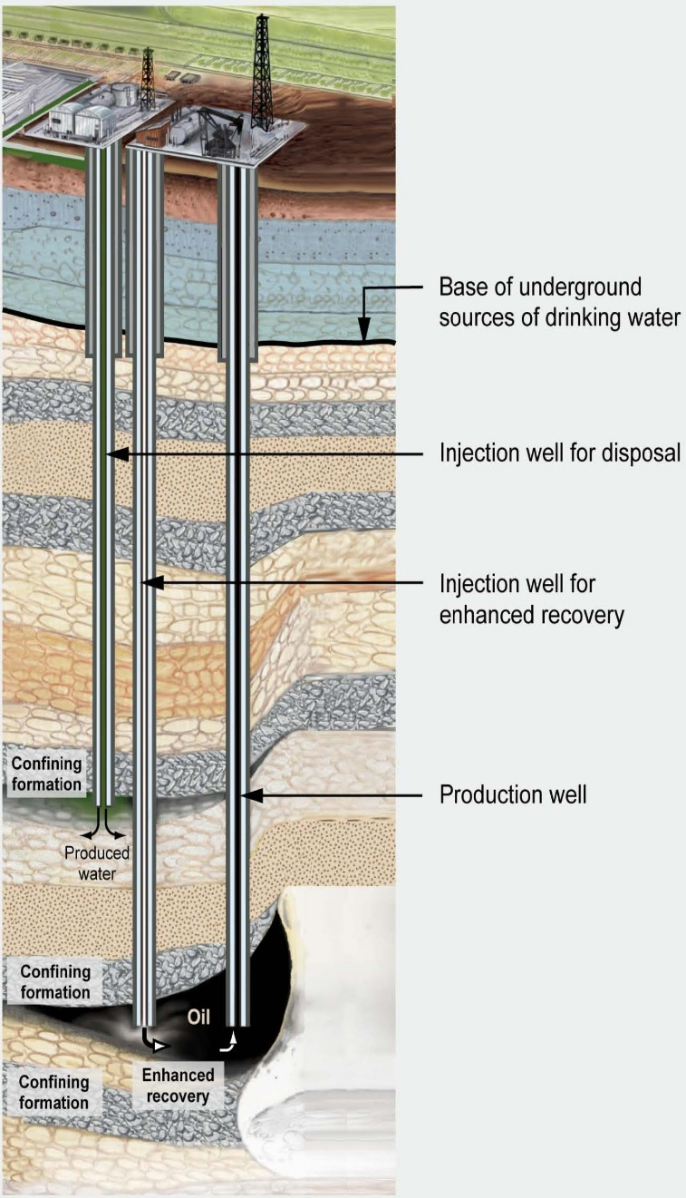
- Onshore Drilling: Land-based drilling using rigs that create a wellbore to reach oil/gas trapped in rock layers.

  - Process: A drill bit rotates, while drilling "mud" is circulated to cool the bit and remove rock cuttings.
  - Casing: Steel pipes and cement are inserted into the hole to stabilize it and prevent contamination.
  - Extraction: If natural pressure is high, oil flows freely; otherwise, artificial lifts (e.g., beam pumps) are used.

- Offshore Drilling: Extracting resources from beneath the seabed.
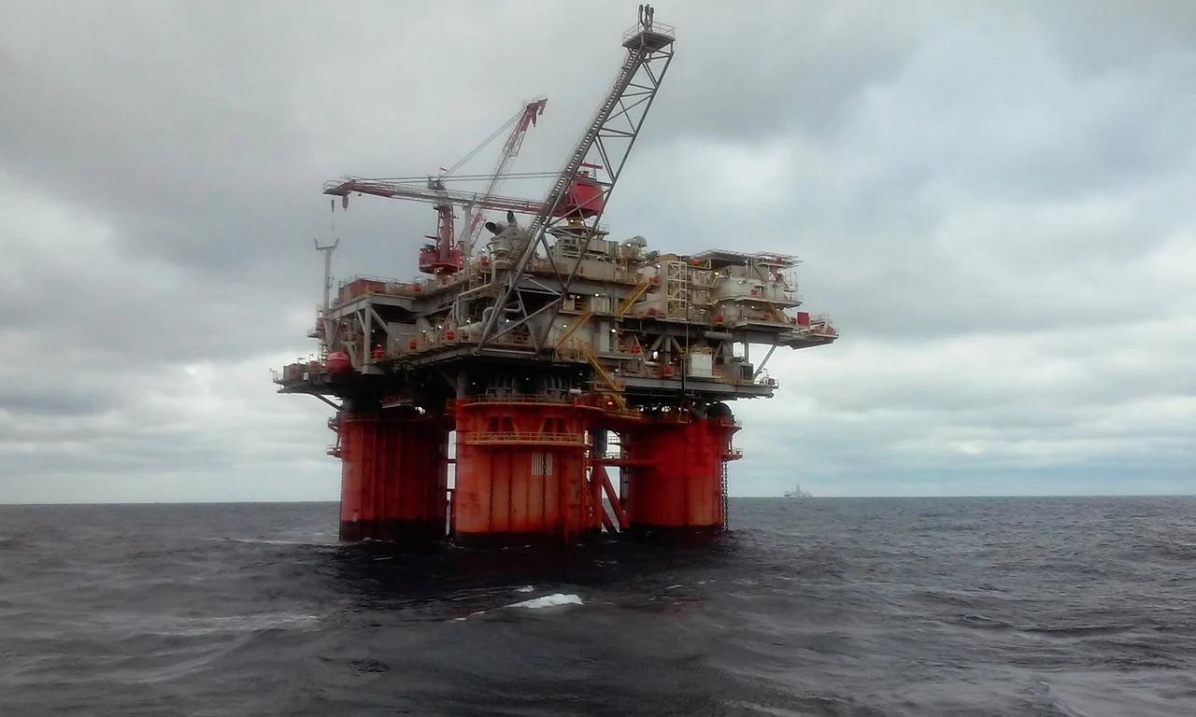
  - Platforms: Jack-up rigs (shallow water), semi-submersible platforms (floating), or drill ships are used.
  - Process: Similar to onshore, but requires a riser to connect the seabed to the rig, a Blowout Preventer (BOP) at the seabed for safety, and complex logistics.
- Fracking (Hydraulic Fracturing): An unconventional method used to unlock oil/gas trapped in shale or tight rock.
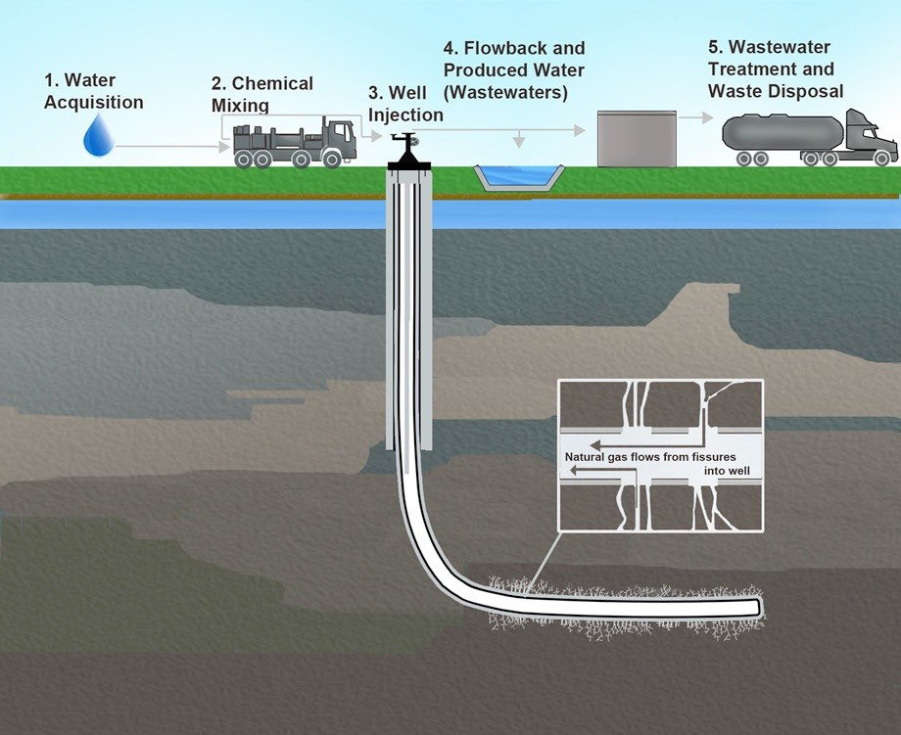

  - Process: Water, chemicals, and sand are pumped at extremely high pressure into a well to create fractures in the rock, allowing hydrocarbons to flow out.
  - Technique: Often combined with horizontal drilling to maximize contact with the shale layer alotal measure and trust

Environmental Impact of Fossil Fuel Extraction and Use
Activity | Environmental Impact | Evaluation
Coal Mining | Surface mining removes topsoil, destroys forests, and causes erosion. Acid mine drainage pollutes waterways with heavy metals. | High devastation to terrestrial ecosystems and permanent land degradation.
Oil/Gas Drilling | Drilling creates land fragmentation and habitat disruption. Fracking uses vast water quantities, risking groundwater contamination. | High risk to aquatic ecosystems and biodiversity.
Transport/Spills | Oil tanker groundings and pipeline leaks release millions of gallons of oil into oceans and land. | Long-term damage to coastal habitats and wildlife.
Combustion | Releases massive amounts of  𝐶𝑂2(89% of global  𝐶𝑂2emissions), causing global warming and ocean acidification. | Primary driver of anthropogenic climate change.
Pollutant Release | Emits nitrogen oxides (NOx)  , sulfur dioxide (SO2)  , and mercury into the atmosphere. | Causes acid rain, ozone damage, and smog formation.

Power Generation from Coal, Oil, Gas
The New Power Grid: Cooking, Driving, and Heating with 21st Century Energy
The way we power our lives is undergoing a massive, electrified revolution. No longer just for lights and appliances, electricity—generated from an increasingly clean mix of solar, wind, and bridge-fuel natural gas—is becoming the primary fuel for our vehicles, our kitchens, and our homes. EON energy+4
As we move toward a low-carbon future, the traditional reliance on combustion is giving way to high-efficiency, electric-based solutions. energypedia

Transportation:
▪︎Transport Fuel: Through coal-to-liquids (CTL) technologies, coal can be converted into synthetic liquid fuels, such as gasoline, though this is not widespread.
▪︎The Electric Shift
Driving into 2026: 116 Million EVs on the Road
The road ahead is electric. With an estimated 116 million electric vehicles (EVs) expected to be on the road by the end of 2026, including cars, buses, and trucks, the transportation sector is rapidly switching from petroleum to power generation. gartner
Smart Charging & V2G: Charging stations are evolving into amenity hubs. Bidirectional charging—or Vehicle-to-Grid (V2G)—is changing the game, allowing EVs to sell stored energy back to the grid during peak demand.
The Rise of E-Fuels: For aviation and maritime transport, e-fuels (synthetic fuels produced from green hydrogen and captured ) are emerging as a sustainable alternative, with projects aiming to cover 20% of global liquid fuel demand this decade.
Cooking: The Induction Revolution
Cleaner, Faster, More Efficient
The kitchen is transforming, driven by high-efficiency electric cooking (e-Cook) and induction technology. Induction cooktops use magnetic currents to generate heat directly in the pan, reducing energy waste and eliminating open flames. Illinois
Solar-Powered Meals: In many regions, solar energy is being used to run electric heaters in insulated cooking chambers, offering a sustainable alternative to conventional fuels.
Energy Efficiency: Electric pressure cookers are gaining popularity for their high efficiency, with studies showing they can be 50% more efficient than traditional cooking methods. Modern Energy
Heating: Comfort Without Carbon
Heating homes, a massive consumer of energy, is moving away from oil and coal toward renewable electricity. However It is still used as a traditional fuel for domestic cooking and space heating in some regions.
Heat Pumps: Air source and ground source (geothermal) heat pumps are leading the charge. These systems transfer heat from the outside air or ground, providing up to 3–4 times more heating energy than the electricity they consume.
Smart Homes: In 2026, home heating systems are more connected than ever, integrating solar photovoltaic (PV) systems to generate electricity directly on the roof and storing it in batteries for use, even at night. energiewechsel
The integration of power generation into transport, cooking, and heating is not just about efficiency—it is about sustainability. As we move toward 2030, this transition is lowering greenhouse gas emissions, reducing reliance on fossil fuels, and reshaping how we live. bloomberg
Steel and Metallurgical Industry: Coking coal (metallurgical coal) is converted into coke and used as a reducing agent to smelt iron ore in blast furnaces.
Carbon Fiber Production: High-carbon materials derived from coal are used as precursors to manufacture low-cost, high-strength carbon fibers for aerospace, automotive, and sporting goods.
Activated Carbon: Coal is a primary raw material for producing activated carbon, which is used for water purification, air filtration, gas processing, and in medical applications.
Chemical Feedstock: Coal gasification and carbonization produce synthesis gas (syngas) and coal tar, which are processed to create chemical feedstocks. These are used to manufacture plastics, dyes, synthetic rubber, and fertilizers.
Pharmaceutical Products: Coal tar by-products, such as benzene and phenol, are used in the pharmaceutical industry to manufacture products like aspirin, soap, and other medicines.
Other Industrial Uses: Coal by-products are used in the manufacturing of cement, paper, and silicon metal. SSRN eLibrary

Our Environment




Impact Metric | Key Data Point | Trend / Detail
Global  CO2Emissions | 38.1 Gt  CO2(2025) | Record high; +1.1% over 2024
Primary Energy Share | ~80% (2024) | Remains dominant energy source
Global Warming Cause | >68% of GHG emissions | Primary driver of 1.22°C human-induced warming
Atmospheric CO2 | ~422.5 ppm (2024) | 50% higher than pre-industrial levels
Premature Deaths | ~8.7 million/year (2018) | ~1 in 5 deaths linked to air pollution
Ocean Acidification | 30% increase (150 years) | Reduced ocean pH, threatens marine life
Deforestation Link | 5 billion tons  CO2/year | ~10% of annual human emissions

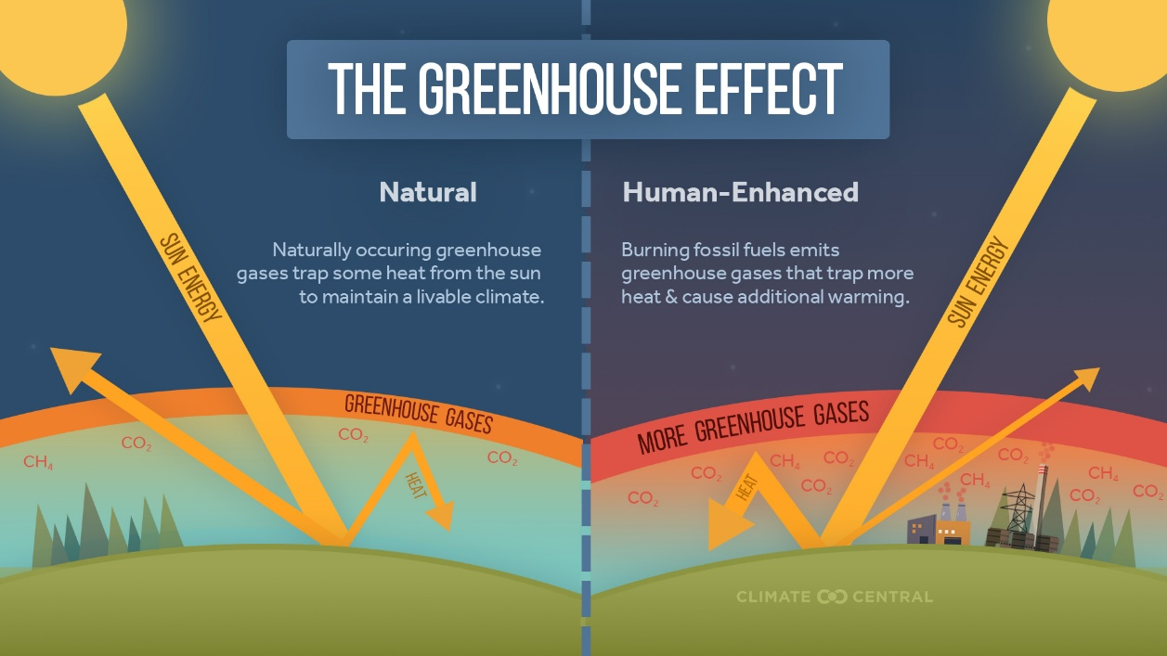
Greenhouse Effect & Global Warming: The accumulation of carbon dioxide (CO2), methane (CH4), and water vapor traps sun heat in the atmosphere, accelerating global warming. The Earth has warmed by
roughly 1.1°C (2°F) since 1850–1900.
Advantages :
- Higher Yields & Production: Greenhouse systems often yield 3 to 5 times more than open-field systems. Modern Mediterranean greenhouses, for example, can produce 30-35 tons of tomatoes per hectare per year.
- Resource Efficiency: Greenhouse cultivation, particularly hydroponics, shows superior Water Use Efficiency (WUE) and Nutrient Use Efficiency (NUE). Some systems save 50–90% in water usage.
- High-Profit Margins: Despite high upfront costs, greenhouse operations can yield significant income, with some studies estimating net profits of Rs. 12 lacs to 25 lacs ($14,000–$30,000 USD) per acre per annum.
- Environmental Control: Greenhouse environments can achieve 16.4 °C higher temperatures than the outside, enabling year-round production in cold climates.
- Quality Control: Precise control over environmental factors ensures consistent, high-quality, and pesticide-free products, which often fetch higher prices.

Disadvantages :
- High Initial & Operating Costs: Initial construction can range from Rs. 500 to 1500 per square meter, with high ongoing labor and utility costs. Modern, high-tech setups in developing countries can cost up to 604,500 $/ha.
- Energy Intensive: Greenhouses are one of the most energy-intensive sectors of agriculture. Monthly heat demand can range between 60.0 and 327.6 MJ/(m²·month).
- Environmental Impact: While reducing water use, greenhouses often have a higher carbon footprint (112.7% to 1672.5% higher) than open-field cultivation, mostly due to fossil fuel consumption for heating.
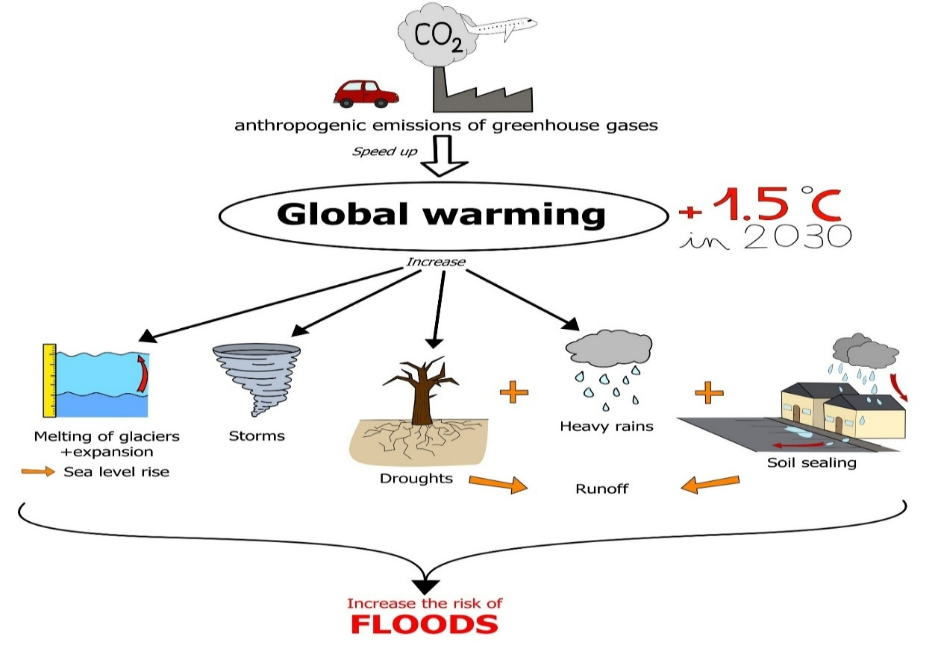
- Pest Control Challenges: Although controlled, pests and diseases can spread rapidly in a greenhouse setting, requiring skilled management and constant monitoring.

Rising Sea Levels: Thermal expansion of warming oceans and the melting of glaciers/ice sheets are causing sea levels to rise at an accelerating rate.
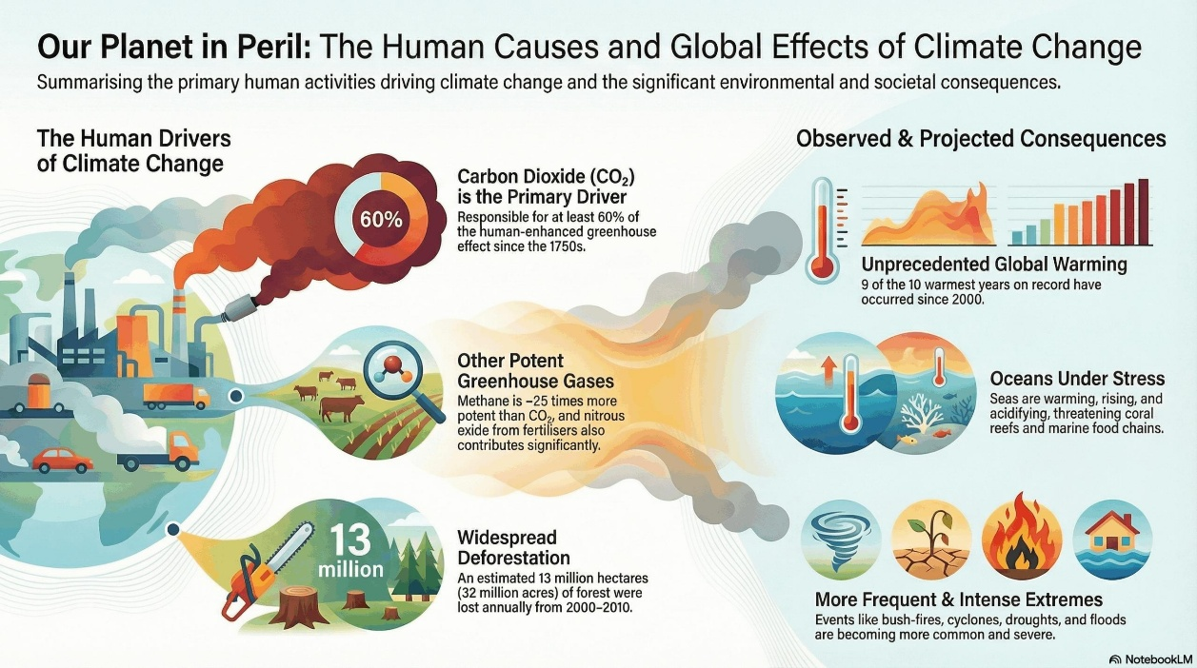
Ecological Disruptions: Climate change is causing rapid biodiversity loss, with one million species at risk of extinction in the coming decades. It causes habitat shifting, earlier blooming of trees, and increased forest fires.
Ocean Acidification: The oceans absorb excess CO₂, which increases acidity, endangering marine life and coral reefs.
Effects on Climate and Extreme Weather
Increased Drought and Heatwaves: Greenhouse gases are in
creasing the frequency and intensity of heatwaves. Higher temperatures increase evaporation, worsening drought conditions, and reducing water availability.
Intensified Storms: A warmer atmosphere can hold more moisture (approx. 7% more for every 1°C rise), which fuels more intense, destructive storms, hurricanes, and heavy rainfall events.
Wildfires: Longer, more severe droughts combined with hotter temperatures create tinder-dry conditions, fueling more frequent and
intense wildfires.
Induced Seismicity (Earthquakes): While direct fracturing of rock rarely causes felt earthquakes, the disposal of waste fluids (wastewater) produced by fracking into deep underground wells is strongly linked to a rise in earthquakes.
Water Usage and Contamination: The fracking process requires substantial amounts of water. Leaks or failures in well integrity can lead to the contamination of groundwater with fracking fluids, which contain toxic chemicals.
Human Health Effects
Toxic Air Pollutants: The combustion of fossil fuels releases hazardous pollutants, including mercury, sulfur dioxide (SO2), nitrous oxides, and arsenic.
Systemic Damage: Exposure to these pollutants can lead to, stroke, neurological complications, respiratory and cardiovascular Diseases( Particulates, and volatile organic compounds (VOCs) contribute to asthma, bronchitis, pneumonia, and lung cancer), and reduced life expectancy. World Health Organization(WHO)
Explain how :
Asthma
For example, ozone, particulate matter, and other compounds released when burning coal can contribute to the development of asthma. The World Health Organization estimates that 300 million people worldwide suffer from the disease each year and 20 million in the United States have the disease. Asthma is inflammation and narrowing of the airways in the lungs. People who suffer from it may have difficulty breathing and may wheeze when breathing. The inflammatory response is so severe that airway obstruction can lead to emergency treatment.
Pneumonia
Studies have connected exposure to air pollution with pneumonia in older adults. Researcher teams from McMaster University in Canada found that exposure to sulfur dioxide, nitrogen dioxide, and fine particulate matter from traffic pollution, which are all also associated with the burning of fossil fuels,
increase the risk of older adults being hospitalized for pneumonia. The study was conducted between 2003 and 2005. This lung infection can be caused by germs, particles, or chemicals and is especially a risk for young children and the elderly.
Upper Respiratory and Eye Irritation
Ozone, specially the secondary formation of the gas, can reason considerable eye and throat irritation. Hydrogen chloride, hydrogen fluoride, and different acidic gases can accomplish that as well. These can irritate the nostril and pores and skin too, and reason a variety of breathing problems. The irritants now no longer usually attain the frame from the particles; a mixture of nitrogen oxides and sulfur dioxides with atmospheric factors can create acid rain, which could damage trees, fish, and wildlife.
Immune System Problems
Several pollutants released when fossil fuels are burned are associated with reduced immune function. These include aromatic compounds, dioxins, heavy metals, lead, and hydrocarbons. In children, the immune system is immature, so any substance that affects it can have more dire consequences.
Cancer
Polycyclic aromatic hydrocarbons are also known in scientific communities as mutagenic and carcinogens. If these harmful substances achieve a fetus from the placenta, it is possible to have high risk of cancer risk. Inhalation of toxic organic compounds and chemicals of each age can increase lung cancer risk. Benzene, formaldehyde, cadmium, arsenic, manganese and lead are known for carcinogenicity. Dioxin was bound to lymphoma, soft tissue sarcoma and gastric cancer.
● Global Health Impact of Fossil Fuel Pollution
Metric | Estimated impact
Total Global Deaths (Fossil Fuel ) | 8.34 – 8.79 Million
Share of Global Deaths | ≈1 in 5 (18–21.5%)
Avoidable Deaths (Phasing out FF) | 5.13 Million
Mortality in China | ~2.44 Million
Mortality in India | ~2.18 Million
Premature Deaths (USA) | 350,000
Child Deaths (< 5 yrs) Globally | ~709,000 (air pollution total)

Disease Category | Estimated Annual Deaths | Key Mechanism
Ischemic Heart Disease | 30% of total PM2.5 deaths | Increased cardiovascular risk
Stroke | 16% of total PM2.5 deaths | Vascular damage
Chronic Obstructive Pulmonary Disease | 16% of total PM2.5 deaths | Long-term breathing issues
Lower Respiratory Infections | ~8% of total PM2.5 deaths | Severe infection (kids)
Diabetes (Type 2) | 6% of total PM2.5 deaths | Metabolic disruption
BMJ. 2023 Nov 29

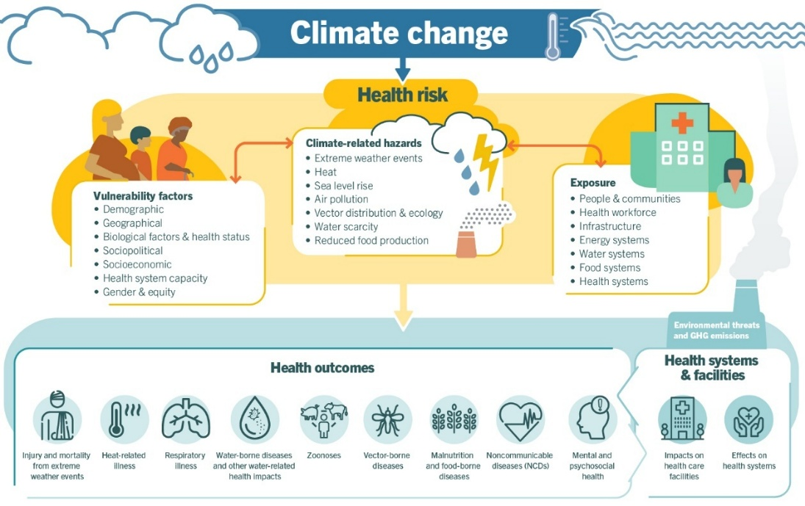
• so for this:
- Economic Cost: The annual global cost of health damages from fossil fuel pollution is estimated at US$ 8.1 trillion a year, or 6.1% of global GDP. In the US, the health impacts of fossil fuel electricity cost up to $886.5 billion annually.
- Environmental Injustice: Marginalized communities and people of color face disproportionately high exposure to pollution, with 5.5 billion people in the Global South living in areas exceeding WHO air quality guidelines.
- We have to find:
- Solutions: A rapid transition to renewable energy (solar, wind) can avoid millions of premature deaths and mitigate climate change.

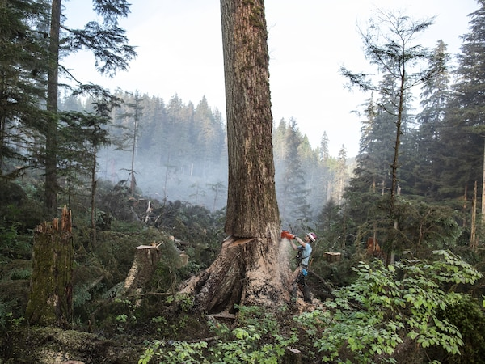
●Forests are powerful allies in the fight against climate change . The science is clear: biodiverse forests capture and store more carbon than single-species plantations. When we plant a variety of native species, we maximize CO₂ absorption, strengthen ecosystems, and ensure resilience against climate threats.
Each species plays a unique role:
☆ Fast-growing trees absorb carbon rapidly.
☆ Long-lived giants store it for centuries.
☆ Shrubs and understory plants enrich soils and recycle nutrients.
Together, they form an interconnected system that can capture up to 40% more carbon compared to monocultures — while protecting wildlife, water sources, and local communities.
At Reforest Trees, each tree contributes to a healthier, more balanced Earth. https://lnkd.in/dx-kManG
#Health impacts and Climare Change must be considered in assessing future oil and gas projects
The UK Health Alliance on Climate Change has strongly urged the government to consider the impacts of scope 3 emissions and pollution from offshore oil and gas projects on both climate and human health in order to fully assess and understand the risks of these projects.UK Health Alliance on Climate Change

References:
https://floodjustice.univ-tours.fr/climate-change/
World Health Organization(WHO)
UK Health Alliance on Climate Change
https://digitallylearn.com/global-warming-effects-acid-rain-greenhouse-ozone-depletion-deforestation/
https://papers.ssrn.com/sol3/papers.cfm?abstract_id=4233459
https://about.bnef.com/insights/clean-transport/electric-vehicle-fleet-set-to-hit-100-million-by-2026-but-stronger-push-needed-to-stay-on-track-for-net-zero/#:~:text=BloombergNEF:%20Urgent%20policy%20action%20needed,like%20India,%20Thailand%20and%20Indonesia.
energiewechsel
Modern Energy
Illinois
gartner
EON energy+4
Alotal measure and trust
https://www.eia.gov/energyexplained/coal/mining-and-transportation.php
IFLScience exciting 2023.Dr. Russell Moul
BMJ. 2023 Nov 29 : https://pmc.ncbi.nlm.nih.gov/articles/PMC10686100/#:~:text=Globally,%20all%20cause%20excess%20deaths,number%20of%20attributable%20deaths%20substantially

Unit 28 : Sustainable Energy


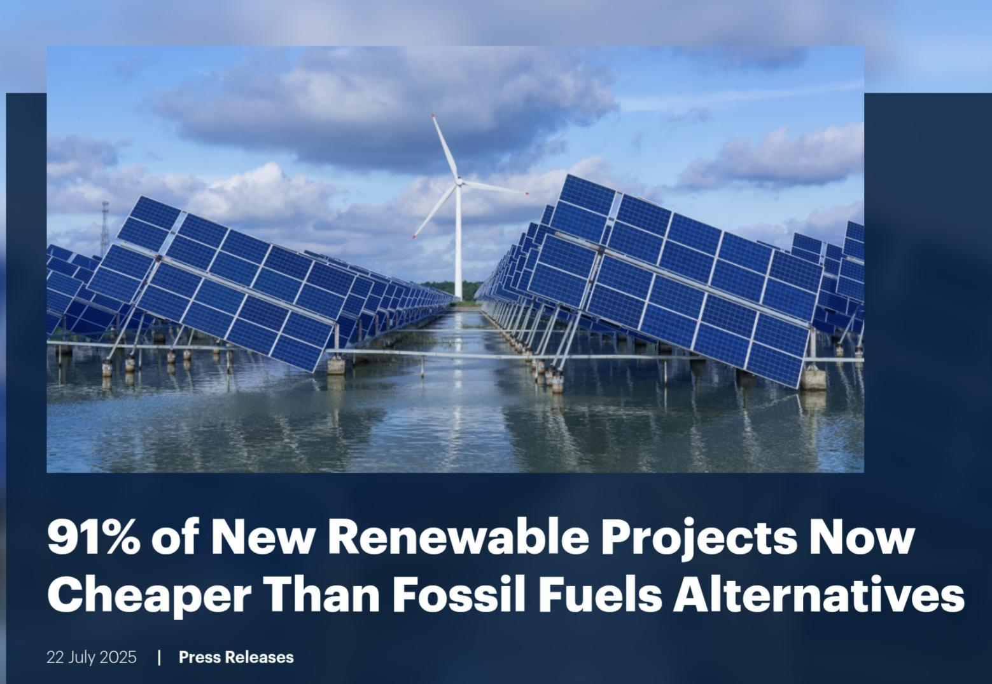
B: Explore the generation of electricity from alternative fuel sources
Why Renewables Are Winning the Energy Game in 2026
EnergyEdge Magazine | March 2026 Edition
The cost of electricity is a major factor in global economic health. While critics often point to intermittency, new 2026 data confirms a shifting reality: renewables are not just cleaner, they are becoming the most cost-competitive and economically efficient power source available.

The Economic Pulse: 2026 Update
According to recent IEA and IRENA findings, renewables are poised to become the largest source of electricity generation globally by late 2025/early 2026. The Levelized Cost of Electricity (LCOE)—the total cost to build and operate a plant per kWh—now shows utility-scale solar PV and onshore wind outcompeting new fossil fuel plants in over 91% of cases.
Core Factors Impacting Efficiency:
Zero Fuel Costs: Unlike coal or gas, wind and sun are free, eliminating fuel price volatility.
Falling Construction Costs: Solar PV capital expenditure is expected to fall below $500/kW in Asia by 2026.
Operating & Maintenance (O&M): Onshore wind O&M averages a low $0.01–$0.025/kWh
Study Case: Onshore Wind vs. Modern Gas Plant
Let’s analyze a hypothetical 100 MW power project, comparing a new Onshore Wind Farm with a combined-cycle Natural Gas plant in 2026.
Cost Factor (2026) | Onshore Wind Farm (100 MW) | Gas Power Plant (100 MW)
Capital Cost (Build) | High ($1.0M - $1.5M/MW) | Moderate ($0.8M - $1.2M/MW)
Fuel Cost | Zero | High & Volatile
Operating Cost (O&M) | Low | Moderate/High
Environmental Cost | Low | High(Carbon/AirQuality)
Avg LCOE (2024/25) | USD 0.034/kWh | USD 0.050–0.100+/kWh
Cost Factor (2026)

The Verdict: While the wind farm requires more upfront steel and land, its operational efficiency means that after 5–7 years, the wind farm generates electricity at a fraction of the cost of the gas plant.

Balancing the Equation: The Hidden Costs
While LCOE suggests renewables are cheaper, operational efficiency depends on balancing intermittency.
Environmental Damage & Social Cost: Renewable sources mitigate the huge environmental costs of fossil fuels (health care, carbon emissions, climate damage).
Storage Integration: The “System LCOE” must include battery storage to handle periods without wind or sun. However, battery costs have plummeted by 93% since 2010, easing this burden.
Efficiency Gains: AI-driven predictive maintenance and better weather forecasting are boosting wind/solar output by up to 20%, ensuring assets are running at maximum capacity.

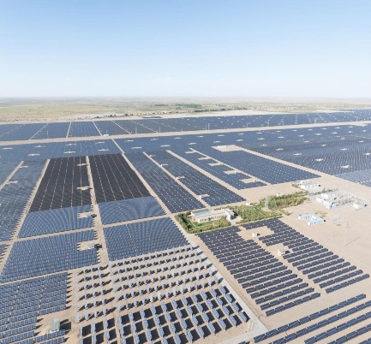
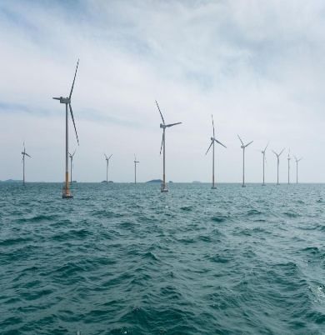
In 2026, the value of the electrical energy generated by renewables goes beyond just the kWh price. It offers energy independence, stable prices, and long-term sustainability. The investment in renewables is no longer just a green alternative—it is the smartest financial decision for the future of power.
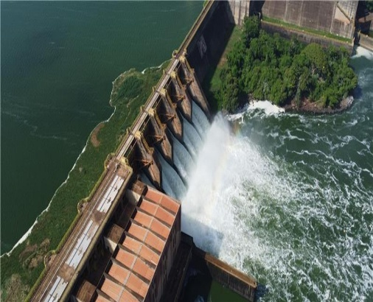

Advances in Technology for Efficient Energy Generation (Cost vs Efficiency):
Energy generation technologies are constantly improving to produce more electricity at lower cost and with higher efficiency. Renewable energy sources such as wind, solar, and wave power are naturally intermittent, so modern advancements focus on: • Increasing energy output
• Reducing losses
• Improving storage
• Lowering long-term costs

1. Turbine Blade Design Improvements
- Description
Modern wind turbines use advanced blade designs made from lightweight composite materials (e.g. carbon fiber).
Blades are:
• Longer – capture more wind energy
Aerodynamically curved – reduce drag and increase lift
Voltage Divider Experiment
Adjustable (pitch control) -> optimize rotation speed
1.2 Efficiency Impact
•Larger blades increase swept area , more kinetic energy captured
•Smart pitch systems adjust to wind conditions , maximize output
• Offshore turbines now produce significantly more power than older designs
1.3 Cost Evaluation
Advantages:
• Higher energy output reduces cost per kWh
• Longer lifespan reduces replacement frequency
Disadvantages:
High initial manufacturing and installation cost Images
Maintenance (especially offshore) is expensive
Evaluation:
Although expensive to build, improved blade design significantly reduces cost per unit of electricity over time, making it Economically efficient.
2. Advances in Solar Panel Technology:
- Description
Solar panels have improved through:
• Higher efficiency photovoltaic (PV) cells (e.g.monocrystalline silicon)
• Bifacial panels (capture sunlight from both sides)
• Tracking systems that follow the sun
• Modern panels convert more sunlight into electricity (over 20% efficiency)
• Tracking systems can increase output by 25-35%
  - Advantages:
• Cost of solar panels has dropped significantly
• Low operating and maintenance costs
  - Disadvantages:
High initial installation cost
Efficiency depends on weather and daylight
3. Battery Storage Technology
- Description
Energy storage systems (especially lithium-ion batteries) store excess energy generated from renewables for later use.
- Efficiency Impact
•Reduces energy waste
•Allows energy use when generation is low (e.g. night or no wind)
•Stabilises electricity supply

  - Advantages:
•Improves reliability of renewable energy
•Reduces need for backup fossil fuels
  - Disadvantages:
• Expensive to manufacture
•Limited lifespan and environmental concerns (mining materials like lithium)
Evaluation:
Battery technology is essential for renewable systems. Although currently costly, prices are decreasing, making them Increasingly viable
4. Wave and Tidal Energy Technology
- Description
New designs include
•Floating wave generators
•Underwater tidal turbines
- Efficiency Impact
•Predictable energy source (especially tidal)
•High energy density compared to wind
- Cost Evaluation
- Advantages:
•Reliable and consistent energy generation
•No fuel costs
  - Disadvantages:
•Very high installation and maintenance costs
•Harsh marine environment causes damage
Evaluation:
While efficient and predictable, wave and tidal technologies are currently less cost-effective due to high infrastructure Costs.
5. Smart Grid Technology
- Description
Smart grids use digital systems to:
•Monitor energy demand
•Distribute electricity efficiently
•Integrate renewable sources
- Efficiency Impact
•Reduces energy losses during transmission
•Matches supply with demand
•Improves overall system efficiency
- Cost Evaluation
- Advantages:
•Reduces wasted energy
•Improves reliability
  - Disadvantages:
•Expensive to implement
•Requires advanced infrastructure
Evaluation:
Smart grids improve efficiency at a system level, making renewable energy more practical and cost-effective long-term.
6. Evaluation (Conclusion)
Modern technological advances have significantly improved the efficiency of renewable energy generation
○Most cost-effective improvements:
• Solar panels
•Wind turbine design
○Most important for future development:
• Battery storage
•Smart grids

Main challenge:
Balancing high initial costs with long-term savings and environmental benefits
Final Judgement:
Although many advanced technologies require high upfront investment, they reduce operational costs and increase energy efficiency over time, making renewable energy increasingly economically viable
Efficiency improves through better design and technology
• Costs are high initially but decrease over time
•Storage and smart systems are key to solving intermittency
•Renewable energy is becoming cheaper than fossil fuels

●Environmental/Safety Risks: Potential for severe accidents, leading to significant contamination and damage
Sustainability | Very High (replenishes naturally) | Moderate (limited uranium, but long-term use possible)
Emissions | Near Zero | Near Zero
Storage/Waste | Requires batteries; intermittent | Radioactive waste (long-term management needed)
Cost | Decreasing, high initial capital | High initial capital and long-term costs
High Costs: Nuclear plants have high construction and decommissioning costs.
Comparison Table

This guide highlights the shift toward sustainable energy, where renewable energy technologies provide clean power, while nuclear serves as a high-capacity,
Low-carbon baseload source with significant management requirements.

● The Levelised Cost of Electricity (LCOE), often denoted as C0 or 𝐿𝐶𝑂𝐸
, is a metric used to determine the average cost of generating one unit of electricity (typically /MWh or c/ kWh) over the entire lifetime of a power plant. It represents the break-even price at which electricity must be sold for the project's Net Present Value (NPV) to be zero.
The Core Formula
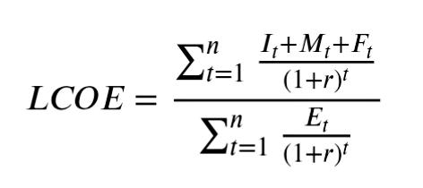
The calculation accounts for the time value of money by discounting both the total lifetime costs and the total lifetime energy produced back to their present value. The Formula:

- I_{t}: Investment/Capital expenditures in year 𝑡.
- 𝑴𝒕: Operations and maintenance (O&M) expenditures in year 𝑡.
- 𝑭𝒕: Fuel expenditures in year 𝑡 (if applicable).
- 𝑬𝒕: Electricity generated in year 𝑡.
- 𝒓: Discount rate (reflecting the cost of capital and risk).
- 𝒏: Operational life of the system (e.g., 25–40 years).

•Factors:
Capital Costs (CAPEX): Upfront expenses including equipment, construction, and financing. For renewables like wind and solar, CAPEX constitutes the majority of the LCOE as there are no fuel costs.
Operations & Maintenance (O&M): Includes both fixed costs (e.g., insurance, land rent) and variable costs (e.g., replacement parts) that occur annually.
Fuel Costs: Primarily relevant for fossil fuel and nuclear plants. This factor introduces high sensitivity to future commodity price volatility.
Capacity Factor: The ratio of actual energy output to the theoretical maximum. A higher capacity factor (common in base load plants like nuclear) lowers the LCOE by spreading fixed costs over more units of energy.
Degradation Rates: For technologies like solar PV, the energy output (Et) decreases annually as equipment ages. This is accounted for in the denominator of the formula.
Discount Rate (r): A higher discount rate penalizes projects with high upfront capital costs (like renewables) more than those with high ongoing operating costs (like gas), as it reduces the present value of future energy generation.

Factor | Impact on Renewable LCOE | Impact on Fossil Fuel LCOE
Initial Investment | Extremely High (Dominant factor) | Moderate
Fuel Costs | Zero or Near-Zero | High (Subject to market price)
O&M Costs | Low to Moderate | High (Variable based on use)
Sensitivity to r | Very High (due to upfront costs) | Lower

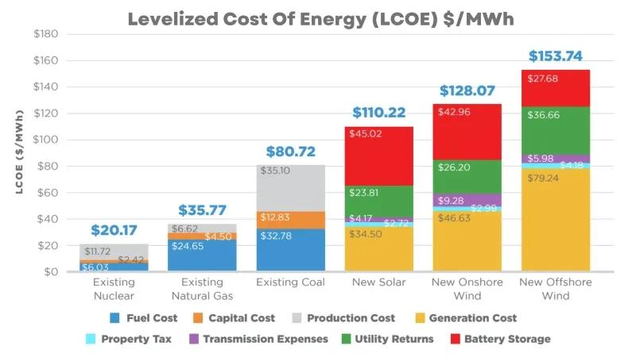
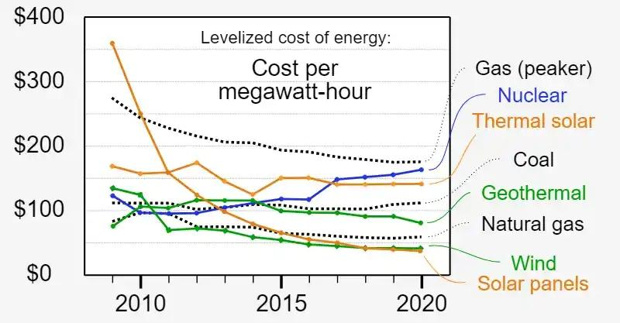
● Compare the efficiency of renewable energy sources to fossil fuels and nuclear power.
- Nuclear holds the highest energy density and provides consistent, high-capacity, low-carbon base load power.
- Renewables (Wind/Solar) have lower energy density and are intermittent, but they are highly efficient at converting natural resources into electricity with zero fuel cost.
- Fossil Fuels are efficient in terms of dispatchability (running when needed) but are inherently inefficient in conversion (30−40%) and produce high emissions.
Comparison of Energy Source Efficiencies
Energy Source | Conversion Efficiency | Capacity Factor (Reliability) | Energy Density/Resource | Main Advantage
Nuclear | 33%-50% | Very High (>90%) | Extremely High | High reliability, zero emissions.
Wind | 40%–59 %  (Betz Limit) | Medium  30%–50% | Medium | High conversion efficiency, low cost.
Solar (PV) | 15%–23%  (Commercial) | Low (10%–25%) | High (Sunshine) | Unlimited fuel, low maintenance.
Hydro | 80%-90% | High (40%–60%) | High | Reliable, dispatchable, long life.
Natural Gas | 35%−60%+ | High (50%−85%) | Medium | High capacity, fast dispatch.
Coal | 30%−40% | High (50%−80%  ) | High | Low cost, reliable.

Feature | Solar PV | Wind Energy | Hydropower | Biomass
Energy Source | Sunlight (Photons) | Kinetic Energy (Air) | Potential/Kinetic (Water) | Organic Matter (Waste/Crops)
Technology | Silicon Panels | Turbines | Turbines & Dams | Combustion/Digestion
Dispatch ability | Variable (Day only) | Very Reliable (Baseload) | Very Reliable (Base load) | Reliable (Baseload)
Best Location | Sunny regions | High-wind  (On/Offshore) | Mountainous/Rivers | Near agricultural sources
Main Use | Electricity (Local/Grid) | Electricity (Grid) | Electricity (Grid) | Heat & Electricity
Relative Cost | Decreasing rapidly | Lowering (Offshore high) | High upfront cost | Moderate cost
Environ  mental | Low emission | Minimal (Visual/Noise) | Ecosystem impact | Carbon neutral potential
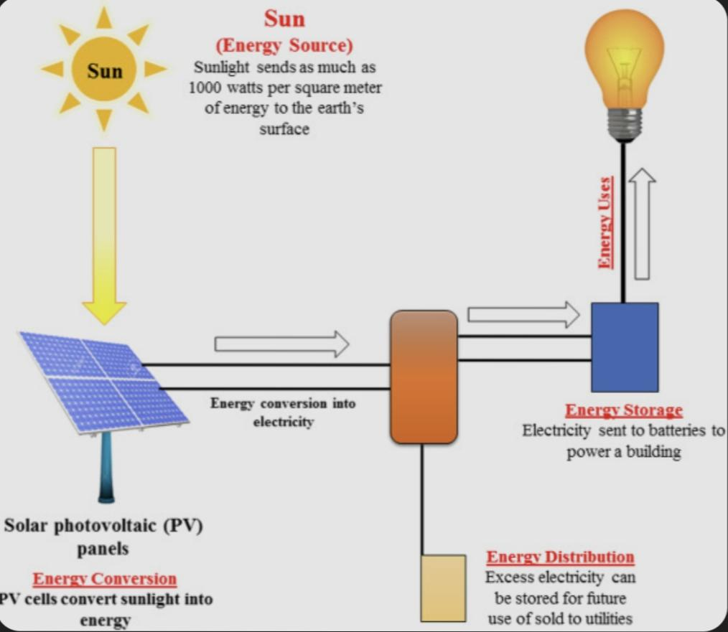

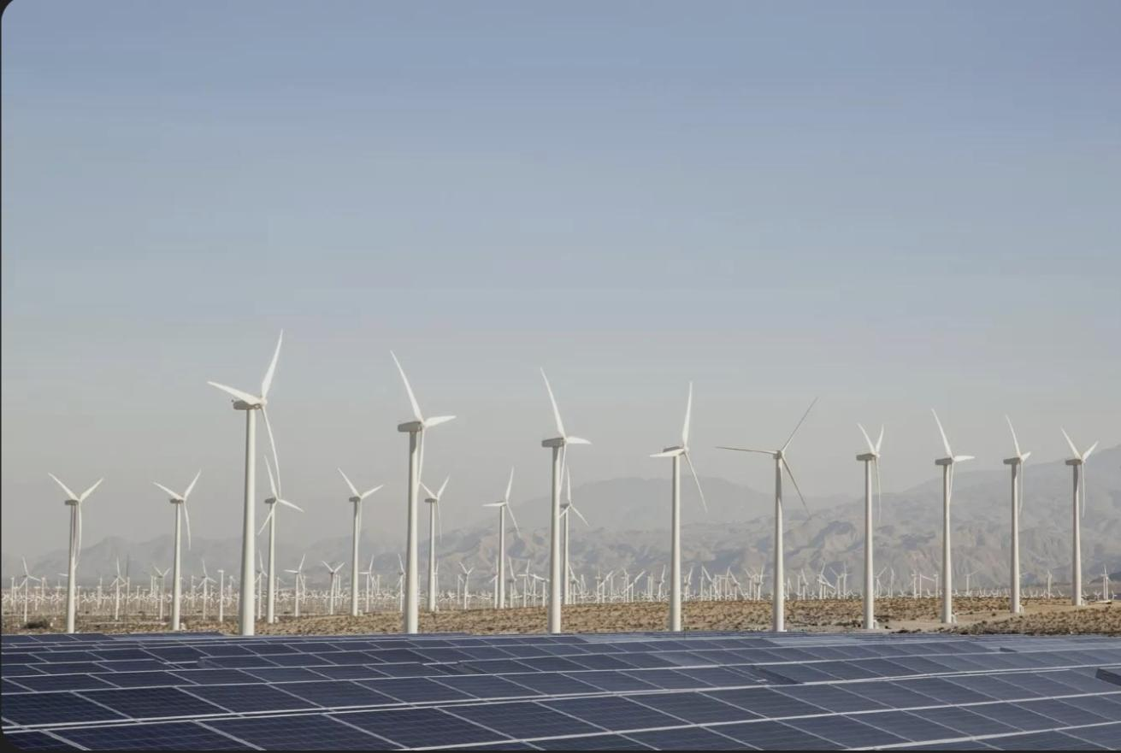
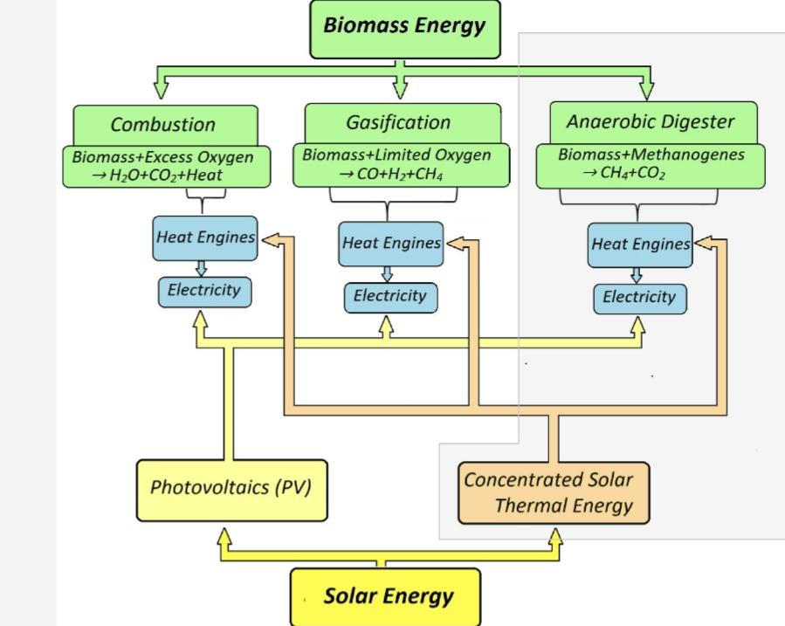
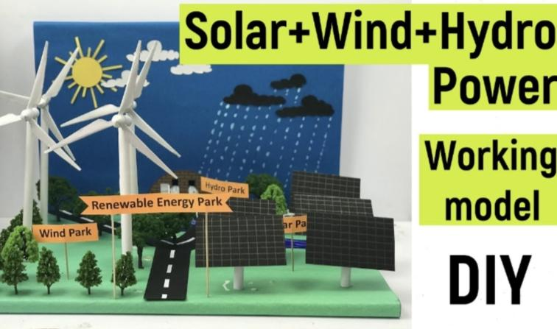
●The advantages and disadvantages of using nuclear fuel as a source of energy must also be described. Sustainability, cost, risks to the environment and the safe disposal of radioactive waste must be considered and described.

Nuclear power offers significant benefits, primarily as a reliable, low-carbon energy source, but it also presents major challenges regarding waste disposal, high upfront costs, and safety risks. The key advantages and disadvantages, considering sustainability, cost, environmental impact, and waste.
Category | Advantages (Pros) | Disadvantages (Cons)
Sustainability | * Low Carbon Emissions: Nuclear power produces virtually no greenhouse gases or air pollutants during operation, making it a powerful tool for combating climate change and air pollution. Its life cycle carbon footprint is comparable to renewable energy sources like wind and solar. | * Non-Renewable Resource: Uranium is a finite, non-renewable resource, meaning its supply is limited in the long term.
Cost | * Stable, Competitive Operating Costs: Once a plant is operational, nuclear energy has very low and stable variable costs, making it cost-competitive with fossil fuels in many cases. * Energy Security: Provides a consistent, reliable baseload power supply, reducing dependence on imported fossil fuels. | * High Capital Costs: New nuclear power plants have very high development and construction costs, which are sensitive to interest rates and financing. * Long Construction Times: Construction timeframes can be lengthy, adding to the financial burden.
Risks to the Environment | * Small Land Footprint: Nuclear power plants require less land than most other energy sources to produce the same amount of electricity. * Waste Fully Contained: The industry fully contains its waste and emissions, unlike fossil fuels, which release pollutants directly into the environment. | * Accident Potential: Although rare, severe accidents (e.g., Chernobyl, Fukushima) can be catastrophic, releasing large amounts of radiation and causing long-term environmental contamination. * Thermal Pollution: The cooling systems can discharge warm water into local bodies of water, potentially affecting aquatic ecosystems.
Safe Disposal of Radioactive Waste | * Small Volume of Waste: Due to high energy density, the total volume of high-level radioactive waste produced is very small compared to the waste generated by fossil fuel plants. * Internalized Costs: The costs for waste management, disposal, and plant decommissioning are included in the price of electricity generated. | * Long-Lived Radioactivity: Nuclear waste remains radioactive and dangerous to human health and the environment for thousands of years, requiring careful, long-term isolation and management. * No Permanent Disposal Solution: A permanent, globally accepted long-term disposal solution (e.g., deep geological repositories) is still a contentious issue and not universally implemented.
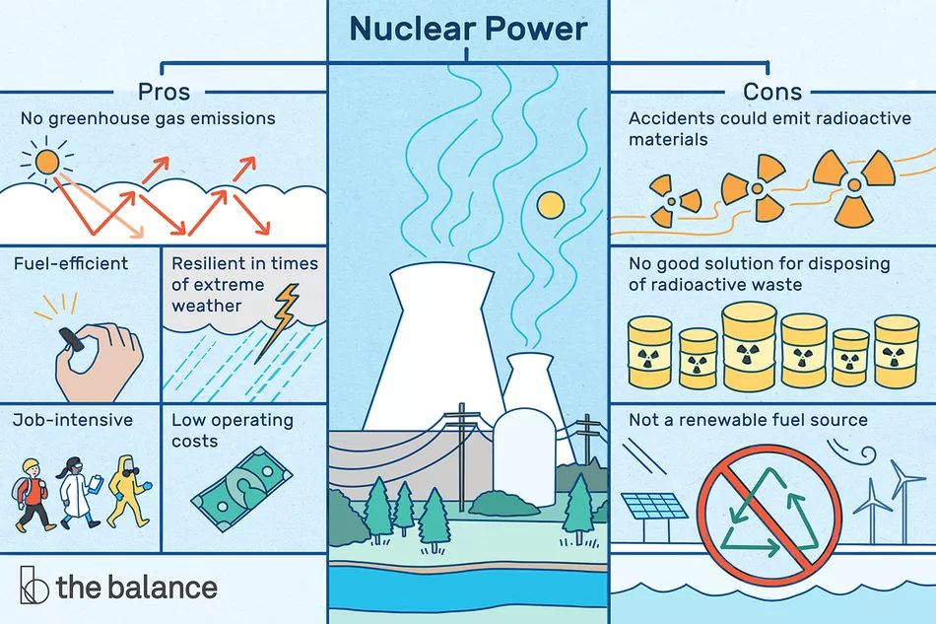
Reference:

The advantages and disadvantages of using nuclear fuel as a source
of energy must also be described. Sustainability, cost, risks to the
environment and the safe disposal of radioactive waste must be
considered and described
-BKV ENERGY
https://bkvenergy.com/learning-center/environmental-impact-of-nuclear-energy/#:~:text=and%20safety%20protocols.-,Is%20nuclear%20energy%20bad%20for%20the%20environment?,long-term%20waste%20disposal%20solutions.

Task.3.Unite 28 : Sustainable Energy

C: Compare the social, environmental and financial benefits and advantages of the use of renewable energy with the disadvantages.
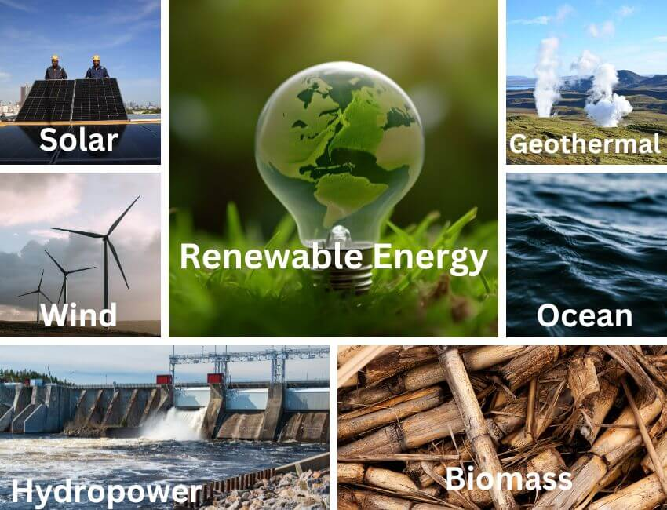
● The transition to renewable energy sources (RES) involves complex social, environmental, and financial trade-offs, often viewed positively in principle but challenged by local implementation, high upfront costs, and environmental impacts (e.g., land use, wildlife).
Public perception is overwhelmingly positive at the national level (84% support in UK, Spring 2024), but often faces local opposition due to “Not in My Back Yard” (NIMBY) concerns regarding visual and noise pollution.MPDI

1. Financial Factors: Costs and Efficiency
- Investment Costs: Renewable projects have high initial capital costs compared to fossil fuels. However, global investments in clean energy are expected to exceed USD 2 trillion in 2025, outpacing fossil fuel investment.
- Operating Costs: Renewable energy systems often have lower maintenance requirements than fossil fuels. In 2024, 91% of new utility-scale renewable projects were cheaper than fossil fuel alternatives.
- Case Study Example: In 2024, renewable energy helped avoid an estimated USD 467 billion in fossil fuel costs globally.
- Public Perception: While the public generally recognizes long-term savings, concerns regarding initial high costs and potential increases in consumer electricity bills exist. IRENA – International Renewable Energy Agency

2. Environmental Factors
- Pollution and Emissions: Renewables provide superior environmental protection, reducing greenhouse gas emissions and improving air quality. In 2024, renewables helped reduce global carbon emissions by 7%.
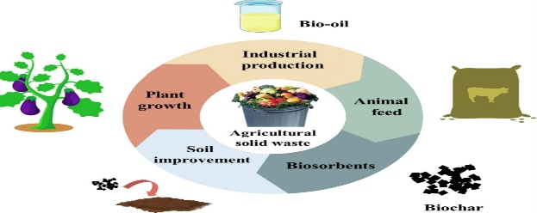
- Waste Disposal: Disposal of materials (e.g., turbine blades, solar panels) is a future challenge, though recycling technology is developing.
- Land and Habitat Impact: Large-scale solar and wind farms require significant land area, which can alter habitats and, in some cases, harm wildlife.
- Public Perception: The public strongly associates renewables with better health and lower ecological footprints. However, in some studies, 43.7% of respondents expressed concern that installations reduce local biodiversity. ScienceDirect 2026
3. Social Factors: Noise, Visual Impact, and Public Perception
- Noise/Visual Impact: Wind turbines produce mechanical and aerodynamic noise, and solar/wind installations can change landscape aesthetics.
- Public Opinion/NIMBYism: Public support varies by scale. For example, while 89.6% may support new solar parks generally, only 68.1% approve of a local installation nearby .https://www.mdpi.com/2673-4060/6/3/111
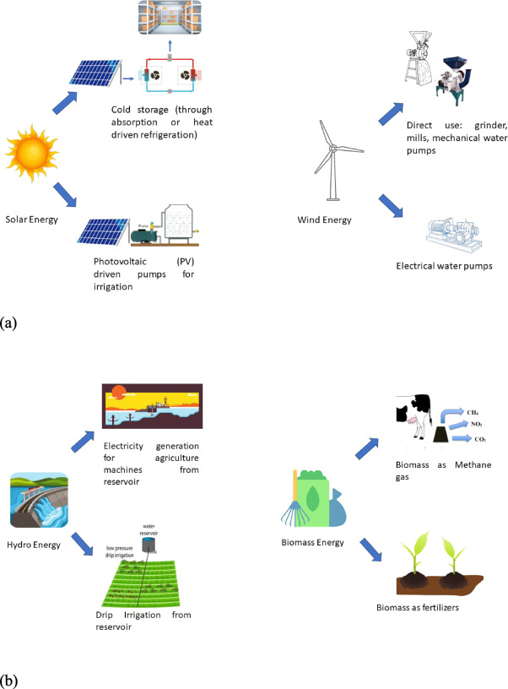

Overview of Advantages and Disadvantages energysage.Nov 2, 2022
Factor | Advantages | Disadvantages
Financial | Low operating costs (no fuel), long-term price stability 91% of new projects cheaper than fossil fuels (2024), job creation, and lower electricity rates. | High initial investment costs, need for energy storage infrastructure, and potential for financial instability due to intermittency.
Environmental | Zero/low carbon emissions during operation, improved air/water quality. | Land use requirements, habitat alteration, wildlife harm (e.g., bird strikes from wind), and waste from decommissioning (e.g., PV panels).
Social | Job creation(60,000 in Turkey 2024)., improved health from less pollution, energy sovereignty. | Noise pollution (wind), visual impact on landscape, NIMBY (Not In My Back Yard) opposition.

Public Perception and Evaluation (Case Studies)
Public perception of renewable energy is generally high (often over 70–80% for solar/wind), but support decreases significantly when projects are proposed for local areas (NIMBY phenomenon).

Findings on Public Perception (Case Study 2024/2025):
- Support & Knowledge: In a 2025 study, 86% of respondents supported solar energy, while onshore wind support was 73%. However, general understanding of the technical and economic aspects of RES remains low.
- Environmental Concerns: Concerns about RES are generally related to the "local" environment, including biodiversity reduction (43.7% of surveyed people) and visual impacts (52.5% of surveyed people).
- Economic Factors: 97.2% of respondents in one study considered RE adoption difficult due to high prices.
- Trust in Information: Universities (4.1/5) and scientific sources are trusted more than governments (2.9/5) or media (12.4% confidence).

Evaluation by Technology Type
- Wind Energy: Considered to have the lowest water consumption and greenhouse gas emissions, yet faced with high local opposition due to noise and visual impacts.
- Solar Photovoltaic: High public acceptance but causes concern over the loss of agricultural land.
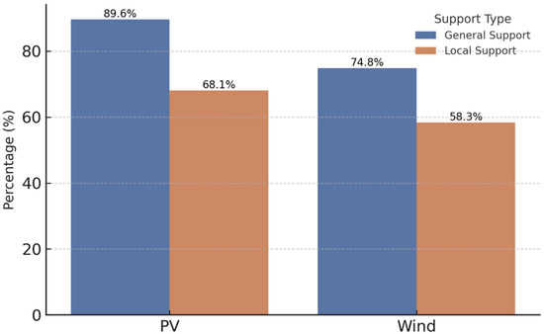
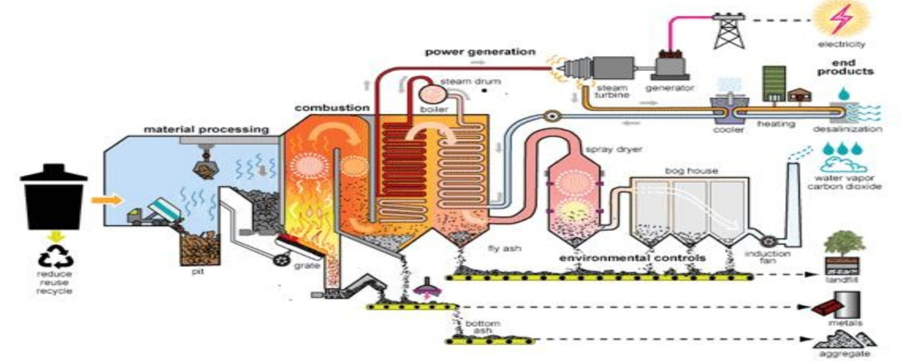
- Biomass: Often faces lower public support due to potential impacts on air quality, even if it contributes to waste management. MPDI

Comparative Table of Environmental and Social Factors. Sustainability Directory26.11.25
Aspect | Renewable Type | Environmental Impact | Social/Perception Impact
Land Req. | Solar PV / Wind | High land requirement, change of habitat. | High visual impact, NIMBY opposition.
Wildlife | Wind / Hydro | Potential harm to birds and aquatic ecosystems. | Concern about loss of biodiversity.
Pollution | Biomass / Waste | Can cause local air pollution (particulate matter). | Concerns regarding noise and smell.
Water | Hydro/Geothermal | Affects aquatic habitats, high water usage. | Social disruption due to community displacement.
Waste | Solar PV | Recycling of panels after 25–30-year lifespan. | Generally lower concern than operational pollution.
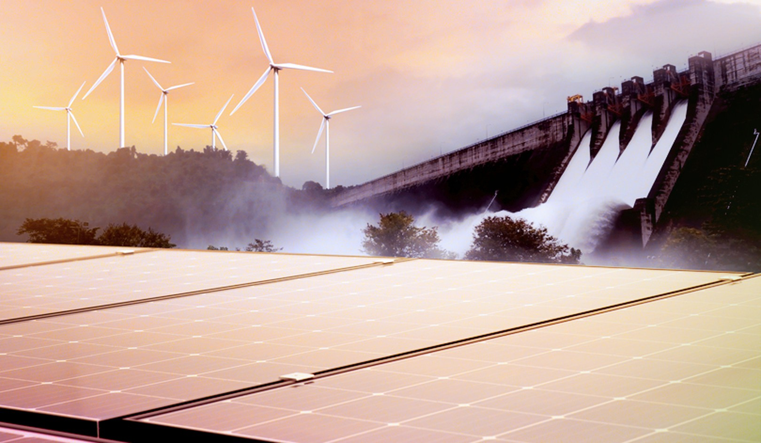

● Based on 2026 renewable energy trends, the transition to clean energy is accelerating, with solar and wind leading new capacity additions while hydropower remains the largest source of renewable electricity. Increased use of renewable energy sources—solar, wind, hydroelectric, biomass, and geothermal—is critical for decarbonizing the energy system, potentially reducing global CO2 emissions by up to 830 million tonnes annually. While generally environmentally friendly, these technologies present trade-offs, including high land-use, intermittency, and material intensity, often requiring 10 times more land than conventional fossil fuel plants. The following table evaluates the key benefits and detrimental effects of the primary renewable energy sources:

Renewable Energy Source Evaluation Table:
Energy Source | Primary Benefits | Disadvantages & Detrimental Effects
Solar (PV) | Rapidly falling costs(41% and 53% cheaper than fossil fuels respectively), scalable (rooftop to utility), widely available, and creates minimal noise/air pollution. | Intermittent (no power at night), requires large land areas for utility projects(3–5 acres per MW), manufacturing involves rare materials, creates panel waste.
Wind (Onshore/Offshore) | Highly cost-competitive, high-efficiency rate, small footprint for ground operations, utilizes renewable, clean energy. Creates significant jobs (35 million globally in the renewable sector by 2030). It can reduce water consumption at existing power plants—recording a reduction of 103 billion gallons in 2019. | Intermittent (depends on weather), visual and noise pollution, can impact local wildlife (birds/bats), high up-front cost for offshore.
Hydroelectric | Stable, baseload-capable power, long lifespan, provides energy storage (pumped hydro) and water management. | Significant ecosystem disruption, large land/community displacement, high construction costs, vulnerability to droughts.
Biomass | Provides dispatchable/baseload power, utilizes waste materials, can reduce landfill waste, supports energy independence. | Greenhouse gas emissions from burning, potential for habitat loss, lower energy efficiency compared to solar/wind, pollution at conversion site.
Geothermal | High reliability, 24/7 "base-load" generation, minimal land footprint compared to solar/wind. | Location-specific, expensive to drill/explore, high upfront capital costs, risk of releasing underground pollutants.
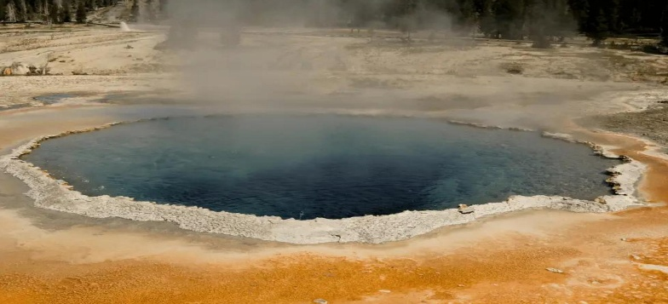
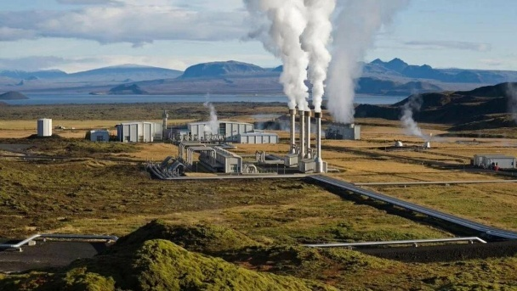
● Conclusion:
Wind power is generally considered one of the most effective renewable energy sources due to its low cost, high efficiency, and minimal carbon footprint. It is currently leading in efficiency among renewables, especially for large-scale project.

Reasons:
- High Efficiency & Low Cost: Onshore wind is often the most economical source of new electricity generation, with costs falling rapidly due to technological advancements.
- Clean Energy: Wind turbines produce no emissions or air pollution during operation, contributing significantly to net-zero emission goals.
- Types of Generation: Wind energy is generated both onshore and offshore, with offshore capacity growing rapidly.
- Environmental Impact: While turbines have a minimal footprint, they can have localized environmental impacts, such as noise and potential risks to birds.
- Rapid Expansion: Global wind capacity has increased dramatically, with 113 GW of new capacity added in 2024 alone.

- Nuclear is better suited for base electricity, while biofuels are designed for transportation fuels.

Advantages and Disadvantages
Feature | Nuclear Energy | Biofuels
Environmental | Pros: Zero carbon emissions during generation, minimal land use.  Cons: Radioactive waste management, thermal pollution, mining impact. | Pros: Renewable source, carbon-neutral in theory (carbon captured by plants), biodegradable.  Cons: Land use for crops can drive deforestation, water intensive, potential food insecurity.
Social | Pros: High reliability (24/7 power), creates high-skilled jobs.  Cons: Public concern over safety (meltdowns) and waste disposal. | Pros: Rural development and job creation, energy independence.  Cons: Conflict over food vs. fuel, higher food prices due to crop competition.
Financial | Pros: Extremely low operating costs once built.  Cons: Very high capital costs, long construction times, high decommissioning costs. | Pros: Can use existing infrastructure, cost-effective if using waste products.  Cons: Production costs can be higher than fossil fuels, highly dependent on agricultural subsidies.  BKVenergy

● The advantages and disadvantages of three renewable energy sources—Solar, Wind, and Hydroelectric—based on social, environmental, and financial factors.
Energy Source | Factors | Advantages | Disadvantages
Solar | Social | Empowers homeowners with energy independence; enables off-grid solutions in remote areas. | Visual impact on landscapes; potential land-use conflicts for large solar farms.
 | Environmental | Zero emissions during operation; reduces reliance on fossil fuels, cutting air pollution. | Manufacturing panels requires rare materials; high water consumption for cleaning in arid regions.
 | Financial | Low maintenance costs; rapid decrease in technology costs makes it cost-competitive. | High upfront installation costs; intermittency requires expensive battery storage.
Wind | Social | Creates jobs in manufacturing and installation; revitalizes rural economies via land leasing. | Noise pollution from turbines; visual impact (blight) on scenic areas.
 | Environmental | No water required for operation; minimal land footprint at the base allows for dual land use (farming). | Risk to bird and bat populations; difficulty in recycling turbine blades.
 | Financial | Free fuel source results in low operating costs; lowest-cost source of new generation in windy areas. | High capital costs for infrastructure; remote locations require expensive transmission upgrades.
Hydroelectric | Social | Provides consistent, reliable base-load power; creates recreational opportunities (lakes). | Large dams can displace local communities and submerge cultural sites.
 | Environmental | Zero greenhouse gas emissions during power generation. | Disrupts aquatic ecosystems, fish migration, and alters natural river flow.
 | Financial | Very low long-term operating costs and long infrastructure lifespan. | Extremely high upfront capital costs; construction can take years, leading to cost overruns.

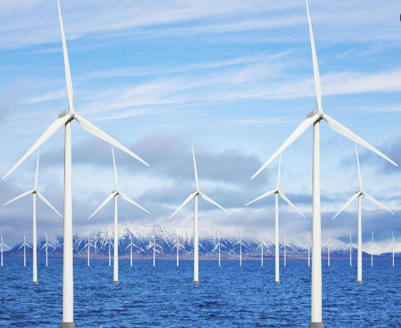
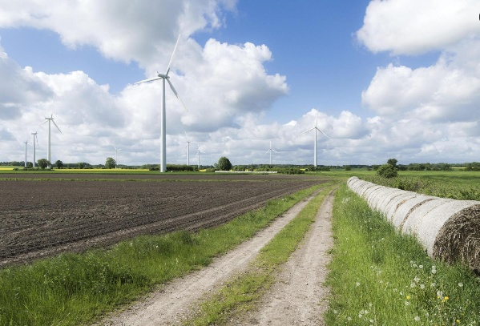

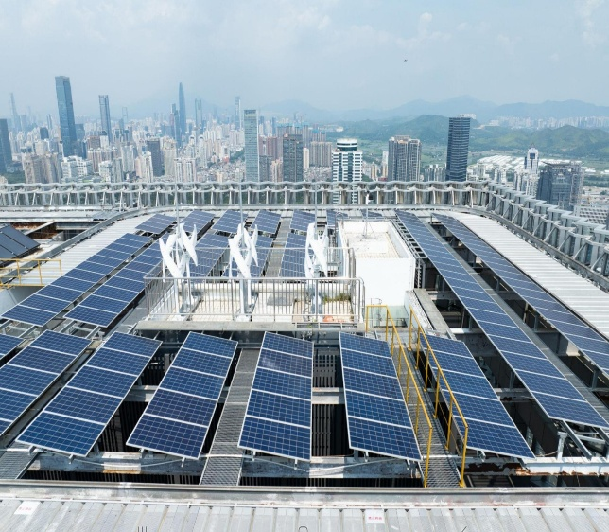

Reference:
  - Renewable Energy Volume 192, June 2022, Pages 572-582
https://www.sciencedirect.com/science/article/abs/pii/S0960148122005900#:~:text=The%20data%20were%20analyzed%20by,set%20in%20Saudi%20Vision%202030.
  - IRENA– INTERNATIONAL Renewable Energy 2024.
https://www.irena.org/Publications/2025/Jun/Renewable-Power-Generation-Costs-in-2024#:~:text=On%20an%20LCOE%20basis,%2091,Moment%20of%20Opportunity%20%7C%20United%20Nations.
  - ScienceDirect 2026. https://www.sciencedirect.com/science/article/pii/S0301421525004069

  - Energysage.Nov2022.
https://www.energysage.com/about-clean-energy/advantages-and-disadvantages-of-renewable-energy/
  - Sustainability Directory26.11.25. https://energy.sustainability-directory.com/question/how-can-communities-effectively-advocate-for-renewable-energy-policies/#:~:text=Intermittency%20is%20a%20common%20challenge%20for%20renewable,and%20attractive%20to%20policymakers%20and%20community%20members.

  - BKV ENERGY.
https://bkvenergy.com/learning-center/environmental-impact-of-nuclear-energy/#:~:text=and%20safety%20protocols.-,Is%20nuclear%20energy%20bad%20for%20the%20environment?,long-term%20waste%20disposal%20solutions.

